**WAREHOUSE MANAGEMENT**

**AN INTERNSHIP REPORT**

***Submitted by***

# Pansuriya Darshil Jaysukhbhai

**180840131033**

***In fulfilment for the award of the degree***

***of***

# BACHELOR OF ENGINEERING

### in

**Computer Science Engineering**

**R.N.G PATEL INSTITUTE OF TECHNOLOGY – RNGPIT**

**ISROLI (BARDOLI)**





# Gujarat Technological University, Ahmedabad

**May, 2022**





**R.N.G Patel Institute of Technology**

**Bardoli – Navsari Road, Isroli, Afwa, Bardoli, Gujarat – 394620**

**CERTIFICATE**

Date:

This is to certify that the Project report submitted along with the project entitled **Warehouse management** has been carried out by **Pansuriya Darshil Jaysukhbhai (180840131033)** for subject Internship (Subject Code:3180701) under my guidance in fulfilment of the degree of Bachelor of Engineering in Computer (8th Semester) of Gujarat Technological University, Ahmadabad during the academic year 2021-22.

Mr. Vivek C. Joshi Dr. Madhavi B. Desai

Assistant Professor Head of Department

CSE, RNGPIT CSE, RNGPIT

Internal Guide Head of the Department

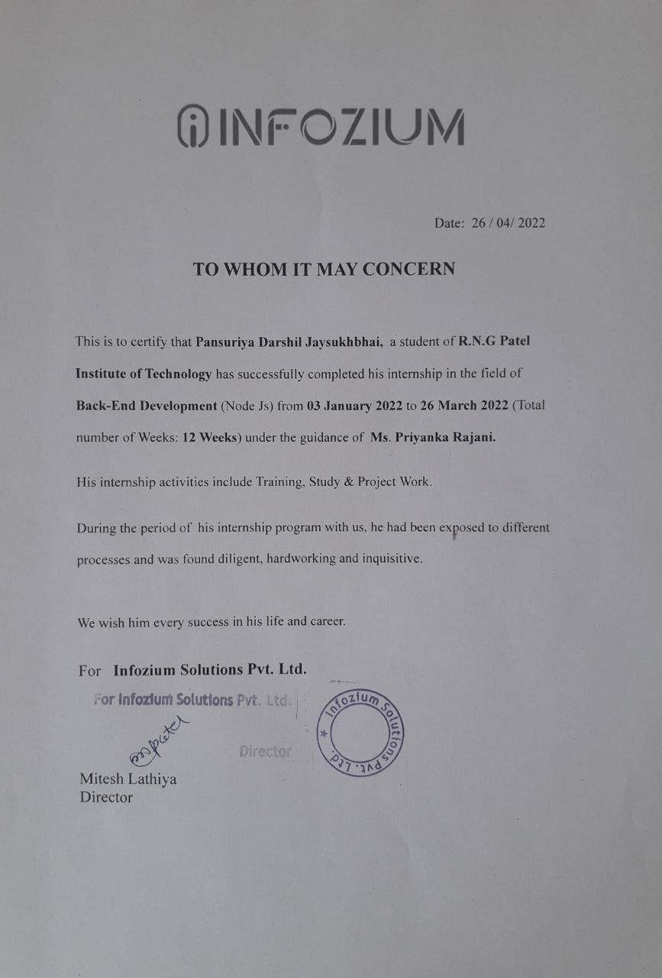

 

**R.N.G Patel Institute of Technology**

**Bardoli – Navsari Road, Isroli, Afwa, Bardoli, Gujarat – 394620**

**DECLARATION**

We hereby declare that the Internship report submitted along with the Project entitled **Warehouse Management** submitted in partial fulfilment for the degree of Bachelor of Engineering in Computer Science to Gujarat Technological University, Ahmedabad, is a bonafide record of original project work carried out by me at **R. N. G. Patel Institute Of Technology** under the supervision of **Mr. Vivek C. Joshi** and that no part of this report has been directly copied from any students’ reports or taken from any other source, without providing due reference.

|  |  |  |
| --- | --- | --- |
|  | Name of the Student | Sign of Student |
|  | 1. Pansuriya Darshil Jaysukhbhai |  |